📝 Predictive Maintenance of Machineries – Project Report
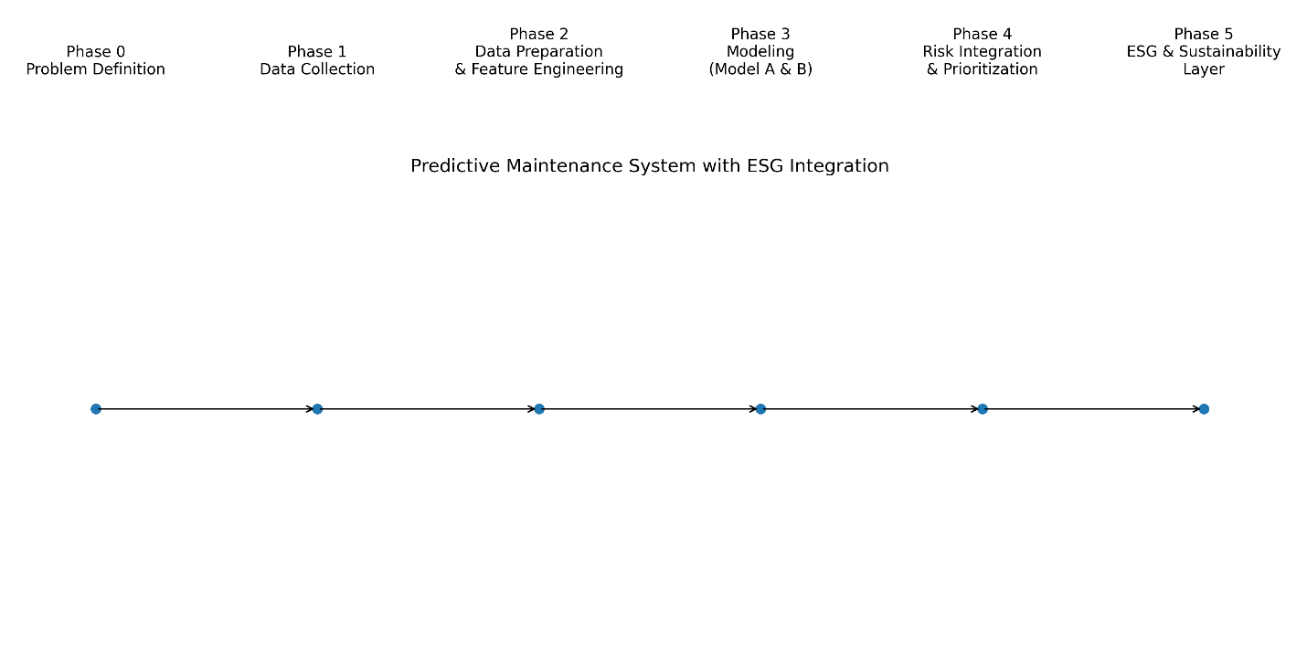
- Phase 0 – Project Setup & Requirements
Objective:
- Develop a predictive maintenance system to anticipate equipment failures, minimize downtime, reduce maintenance costs, and extend asset lifespan using data-driven insights.
- Align with company sustainability goals (ESG, environmental risk, GRC).
Setup:
- Environment: Python 3.x, VSCode, virtual environment (.venv)
- Key Libraries: pandas, scikit-learn, joblib, pathlib

- Phase 1 – Data Collection & Exploration
Datasets:
- Dataset 1 – Predictive Maintenance Equipment
  - Sensor readings & operational metrics for various machines (Pump, Extruder, Pressure Cutter, Gauge Machine, Coil Oven).
  - Features: temperature, humidity, age, quantity produced.
  - Target: MTTF → converted to binary failure for model training.
- Dataset 2 – Environmental / Sensor Data
  - Environmental metrics: Air Quality (AQ), Volatile Organic Compounds (VOC), current (CS), temperature, ultrasonic sensors, etc.
  - Includes preliminary Environmental Stress Index (ESI) derived from features.
EDA & Observations:
- Checked for missing values, outliers, and feature distributions.
- Normalized / scaled features where needed.
- Identified irrelevant columns (footfall, rp, ip) for Phase 2 processing.

- Phase 2 – Data Preparation & Feature Engineering
Dataset 1 (Asset Health / Model A):
- Cleaned column names, removed duplicates, handled missing values.
- One-Hot Encoding applied to categorical feature producttype.
- Final features prepared for model training saved in dataset_1_train_processed.csv and dataset_1_test_processed.csv.
Dataset 2 (Environmental / Model B):
- Cleaned dataset by removing irrelevant columns (footfall, rp, ip, fail).
- Retained key features: tempmode, aq, uss, cs, voc, temperature.
- Environmental Stress Index calculated and saved as dataset_2_esi.csv.

- Phase 3 – Modeling
Model A – Asset Health / Predictive Maintenance
- Objective: Predict likelihood of machine failure to enable proactive maintenance.
- Algorithm: Random Forest (threshold tuning applied for early detection).
- Performance (Threshold 0.3):
Metric | Value
Accuracy | 0.93
Recall (Failure=1) | 0.87
Precision (Failure=1) | 0.84
F1-score (Failure=1) | 0.86
- Output: failure_risk_score (0–1), predicted_failure (0/1)
- File: outputs/model_a_predictions.csv

Model B – Environmental Risk
- Objective: Quantify environmental stress affecting machines for ESG-aligned operations.
- Algorithm: Isolation Forest (unsupervised anomaly detection)
- Features: tempmode, aq, uss, cs, voc, temperature
- Output: environmental_risk_score (0–1), environmental_risk_level (Low/Medium/High)
- File: outputs/model_b_esi_predictions.csv

- Phase 4 – Combined Decision Layer
Objective:
- Merge Model A & Model B predictions.
- Compute Final Maintenance Risk Score per machine.
- Assign Maintenance Priority (High / Medium / Low).
Methodology:
final_risk_score = 0.6 * failure_risk_score + 0.4 * environmental_risk_score
Priority Mapping:
final_risk_score | Priority
> 0.7 | High
0.4 – 0.7 | Medium
< 0.4 | Low
Output CSV: outputs/final_maintenance_priority.csv
- Columns: failure_risk_score, environmental_risk_score, final_risk_score, maintenance_priority

Outcome / Summary
- Predictive Maintenance system is ready for deployment.
- Each machine is scored for both failure risk and environmental stress.
- Final Maintenance Priority enables team to:
  - Act on machines likely to fail soon (High)
  - Schedule preventive checks (Medium)
  - Continue normal operations (Low)
- Supports ESG and sustainability objectives by integrating environmental risk into maintenance decisions.

- Phase 5 – ESG & Sustainability Layer
“The ESG impact score is calculated using a rule-based weighting approach that combines predicted failure risk with environmental stress indicators.
This approach provides interpretable sustainability insights without introducing additional machine learning complexity, because the objective of Phase 5 is not prediction, but interpretation and decision support based on previously generated risk scores.”

Objective:
• Translate predictive maintenance outputs into ESG and sustainability insights.
• Quantify the environmental and governance impact of machine failures and maintenance decisions.
• Support ESG reporting, sustainability KPIs, and responsible asset management.

Methodology:
This phase builds on the outputs of Phase 4 by mapping maintenance risk to sustainability-related impacts.
A simplified ESG Impact Score is calculated using environmental and operational risk indicators:
esg_impact_score = 0.5 * environmental_risk_score
+ 0.3 * failure_risk_score
+ 0.2 * maintenance_priority_weight
Where:
- environmental_risk_score comes from Model B
- failure_risk_score comes from Model A
- maintenance_priority_weight is derived from Phase 4 priorities:
  - High → 1.0
  - Medium → 0.5
  - Low → 0.2

ESG Impact Classification:
ESG Impact Score | ESG Risk Level
> 0.7 | High ESG Risk
0.4 – 0.7 | Medium ESG Risk
< 0.4 | Low ESG Risk

ESG Dimensions Addressed:
• Environmental (E):
- Reduced energy waste and emissions through early maintenance
- Lower environmental stress from high-risk machine operations
• Governance (G):
- Data-driven maintenance decision-making
- Improved asset lifecycle management and risk oversight
• Sustainability Alignment:
- Supports preventive maintenance strategies that extend asset lifespan
- Contributes to operational efficiency and reduced carbon footprint

Output CSV:
outputs/final_esg_impact_scores.csv
Columns:
- failure_risk_score
- environmental_risk_score
- maintenance_priority
- esg_impact_score
- esg_risk_level

Key Insight:
Phase 5 does not introduce a new machine learning model; instead, it acts as an interpretability and decision-support layer, transforming technical risk predictions into actionable ESG and sustainability insights that can be used by management, ESG teams, and compliance stakeholders.

Dashboard:
Machine data → Failure Risk (Model A) + Environmental Risk (Model B) → Final Maintenance Priority → ESG Impact → Dashboard
Machine data
↓
Model A (Failure Risk)
↓
Model B (Environmental Risk)
↓
Decision Layer
↓
ESG Layer
↓
Dashboard

Summary:
- End-to-End Predictive Maintenance Story
We built an end-to-end predictive maintenance system that works in five main steps:
- Model A – Failure Risk Prediction
We used Model A to analyze machine operational data and predict the likelihood of equipment failure before it happens.
Output: a failure risk score for each machine, indicating how likely it is to fail.
- Model B – Environmental Risk Assessment
We used Model B to evaluate environmental and operating conditions around the machines, such as temperature, air quality, and emissions-related indicators.
Output: an environmental risk score that reflects how stressful or unsustainable the operating conditions are.
- Decision Layer – Risk Combination
To make actionable maintenance decisions, we combined the outputs of Model A and Model B into a single final maintenance risk score.
Based on this score, each machine is assigned a maintenance priority (High, Medium, or Low).
- ESG & Sustainability Layer
We then translated the technical risk scores into an ESG impact score, showing how machine failures and maintenance decisions affect sustainability, environmental performance, and governance.
- Dashboard & Outputs
Finally, all results are presented in an interactive dashboard and a CSV output, allowing stakeholders to easily identify high-risk machines, prioritize maintenance, and support ESG reporting.

